**MARKETFORECASTING**

**ARTIFICIALINTELIGENCE**

PROJECTREPORT

# *Submitted by*

Yeswanth Kumar Muttha 801398789

Hemanth Borra 801428928   
Adarsh Kodumuru 801365902

# INTRODUCTION

Traditional costing methods are accounting approaches designed to calculate the production cost of a product with the goal of achieving profitability. This system distributes indirect manufacturing expenses, known as overhead, across various products. In contrast, price optimization is a revenue-maximization strategy where businesses set prices based on how much customers are willing to pay. This strategy involves assessing consumer behavior to identify the most profitable price point. Key elements in this approach include analyzing competitor prices, evaluating customer demand, and monitoring market trends. By customizing prices for different customer groups, companies can increase revenue while enhancing customer satisfaction.

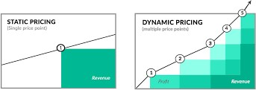

Static and Dynamic Pricing

# GOAL

The objective is to find the most effective price point for mobile phones—one that maximizes profits, minimizes customer dissatisfaction, and improves overall customer satisfaction. This optimal pricing should be determined by conducting thorough market research, collecting customer feedback, and evaluating competitors' pricing strategies.

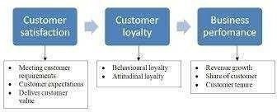

# **Company Objectives** PROBLEM STATEMENT

Problem: With the launch of new mobile phone technology, what is the best approach to set an optimal price that will maximize profitability? Which critical factors should be evaluated in determining this price?

Goal: To find the ideal sales price for a mobile phone by examining the current demand curve and identifying key factors that drive demand, with the ultimate goal of maximizing profits.

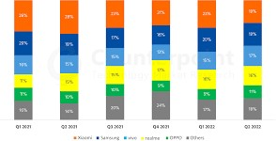

Fig 1.4: Mobile phone sales for the company.

**Project Objectives Overview**This project is designed with the following primary objectives:

1. **Create an Advanced Pricing Model**: Apply machine learning algorithms to forecast and dynamically adjust mobile phone prices in real time, factoring in demand, competitor prices, and other crucial variables.
2. **Overcome the Constraints of Traditional Pricing Models**: Enhance traditional cost-based pricing approaches by incorporating real-time market dynamics into the pricing model.
3. **Increase Profitability**: Determine optimal pricing for mobile devices that will boost sales, maximize profit margins, and maintain competitive positioning in the market.
4. **Assess Model Efficiency**: Measure the performance of the machine learning pricing model against traditional methods to showcase its flexibility and effectiveness in responding to market changes.

These objectives shape the project, enabling accurate predictions of ideal sales prices.

**Approach**

The project approach includes the following critical steps:

**System Requirements**: Specify the necessary hardware and software tools, including programming languages like Python, development environments such as Google Colab, and operating systems like Windows 11.

**Data Preparation**: Organize and clean the dataset for analysis by filling in missing values, encoding categorical data, and standardizing data values.

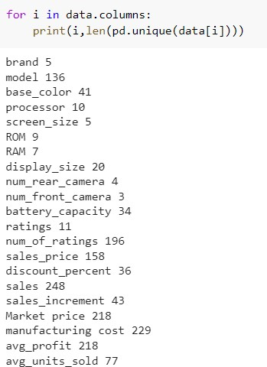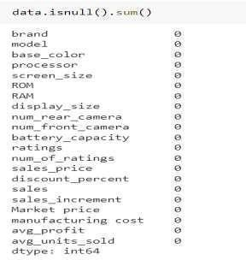

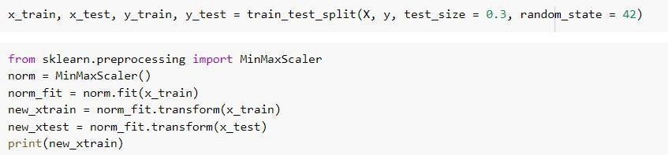

**Model Implementation**  
This phase involves deploying various regression models—including Linear Regression, Ridge Regression, Lasso Regression, and Random Forest Regression—to forecast ideal pricing. The process encompasses training each model on the dataset, fine-tuning hyperparameters, and evaluating overall model accuracy and performance.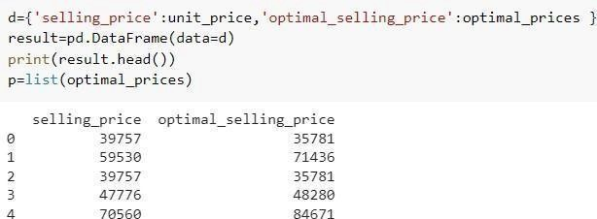

Optimal selling price without employing a machine learning algorithm.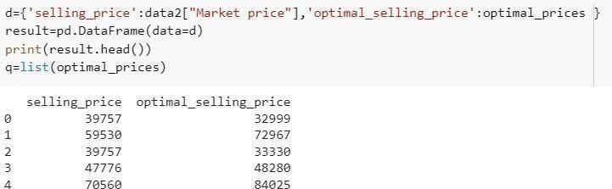

Optimal mobile selling price after applying a machine learning algorithm.

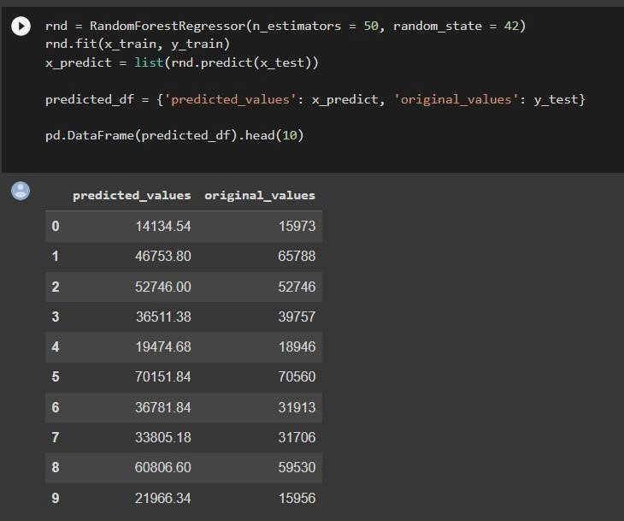

Random Forest Regression estimates the selling price by analyzing historical data through multiple decision trees.  
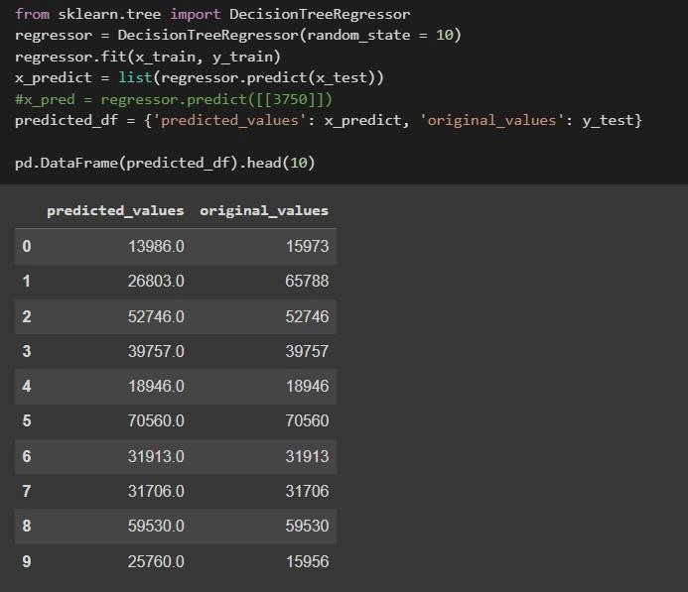

Estimating the selling price using Decision Tree Regression involves leveraging the model's ability to predict prices based on historical data and input features.   
  
  
Model testing and evaluation focus on determining the accuracy and reliability of each machine learning approach in predicting the ideal price. This process also examines how well the models influence both profitability and the product's position in the market, ensuring they contribute to competitive pricing strategies.

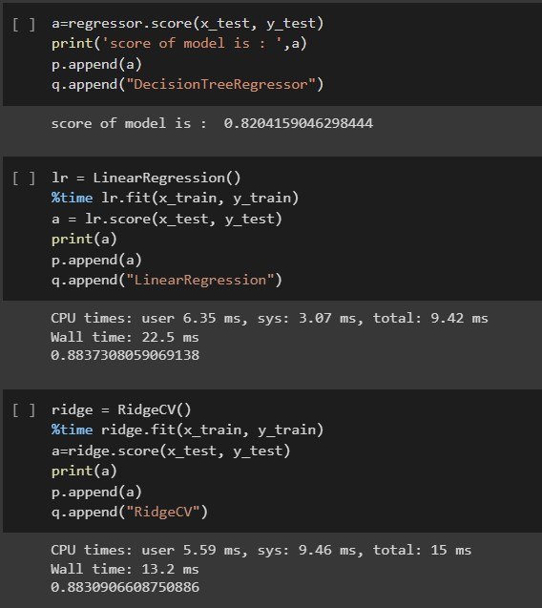

**Model Performance Evaluation   
  
 Expected Results**

We conducted a thorough comparison between the results obtained from our initial demand equation model and those generated by various machine learning algorithms applied to our dataset. The analysis included the following algorithms:

* Linear Regression
* Ridge Regression
* Lasso Regression
* Random Forest

This approach allowed us to assess the performance disparities between traditional statistical methods and contemporary machine learning techniques, focusing on their accuracy in predicting demand. By evaluating these models, we aimed to determine which method most effectively forecasts demand and how well they perform in comparison to one another.

**Linear Regression:**

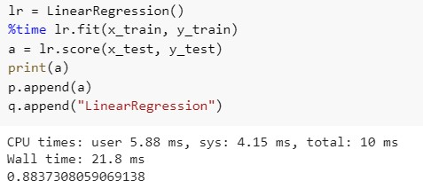

Accuracy of Linear regression

The model demonstrated an accuracy of 88%.

**Ridge Regression**:

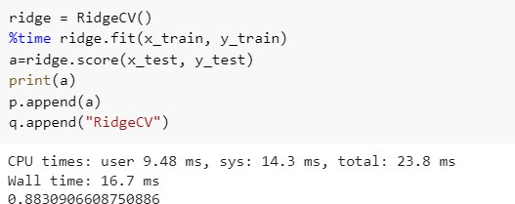

Accuracy of Ridge regression

We then evaluated the Ridge Regression model's performance.

**Lasso Regression:**

Next, we examined the performance of the Lasso Regression model.

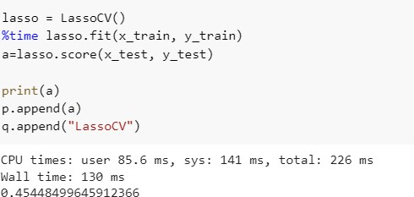

Accuracy of Lasso regression The Lasso Regression model achieved an accuracy of 45%.

## Comparison of regression models

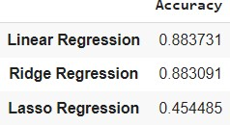

**Random Forest regression:**

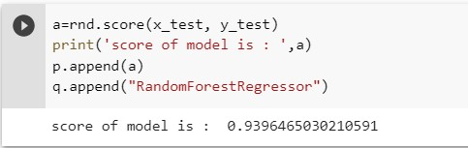

# The Random Forest Regression model delivered the best accuracy for this dataset, reaching an outstanding 93.9%. Bibliography

[1] Q. Huang and F. Zhou, "Research on Retailer Data Clustering Algorithms Using Spark," *AIP Conference Proceedings*, vol. 1820, no. 1, pp. 080022, March 2017.  
[2] A. Sayli, I. Ozturk, and M. Ustunel, "Brand Loyalty Analysis System Through the K-Means Algorithm," *Journal of Engineering Technology and Applied Sciences*, vol. 1, no. 3, 2016.  
[3] M.N. Maingi, "An Overview of Clustering Algorithms in Sales Data Mining."  
[4] S.H. Sastry, P. Babu, and M.S. Prasada, "Sales Data Analysis and Prediction in SAP ERP Systems Using Clustering Algorithms," 2013.  
[5] V. Shrivastava and N. Arya, "A Comparative Analysis of Various Clustering Algorithms Applied to Retail Sales Data," *International Journal of Computer Communications and Networks*, vol. 1, no. 2, 2012.  
[6] D. Rajagopal, "Using Data Mining Techniques for Customer Data Clustering," 2011.  
[7] C.F. Tsai, H.C. Wu, and C.W. Tsai, "A Novel Method for Data Clustering in Large Database Mining," *Parallel Architectures, Algorithms, and Networks 2002. ISPAN’02. Proceedings of the International Symposium*, pp. 315-320, 2002.  
[8] A.K. Mann and N. Kaur, "A Comprehensive Review of Clustering Techniques," *Global Journal of Computer Science and Technology*, 2013.  
[9] N. Shah, M. Solanki, A. Tambe, and D. Dhangar, "Efficient Mining Techniques for Sales Prediction."  
[10] M. Korolev and K. Ruegg, "Application of Gradient Boosted Trees for Store Sales Prediction," 2015.